27.25: a) The radius of the path is unaffected, but the pitch of the helix varies with time as the proton is accelerated in the x-direction.

b) 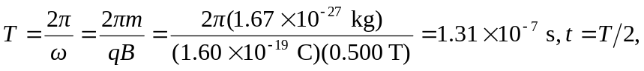and
